NAME: A.G.KATHIRESAN

GROUP PROJECT: APT CHARACTERISTICS AND MITIGATION STRATIGIES

ADVANCED PERSISTENT ATTACK (APT):

An Advanced Persistent Threat (APT) is an term that is used to describe an attack campaign in which the intruder, or an team of intruders establishes an illicit and long- term presence in a network in order to extract the highly sensitive data and information.

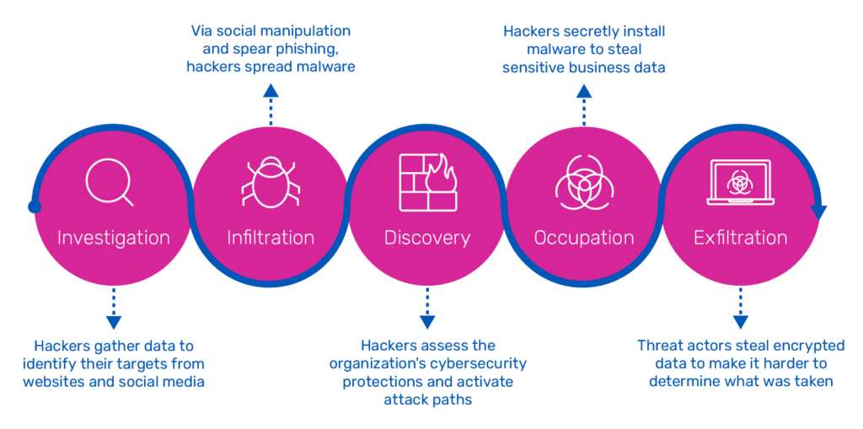

**Advanced Persistent Threat Characteristics:**

APT (Advanced Persistent Threat) attacks are highly sophisticated and targeted cyber attacks that are typically carried out by skilled and well-resourced adversaries. Here are some key characteristics of APT attacks:

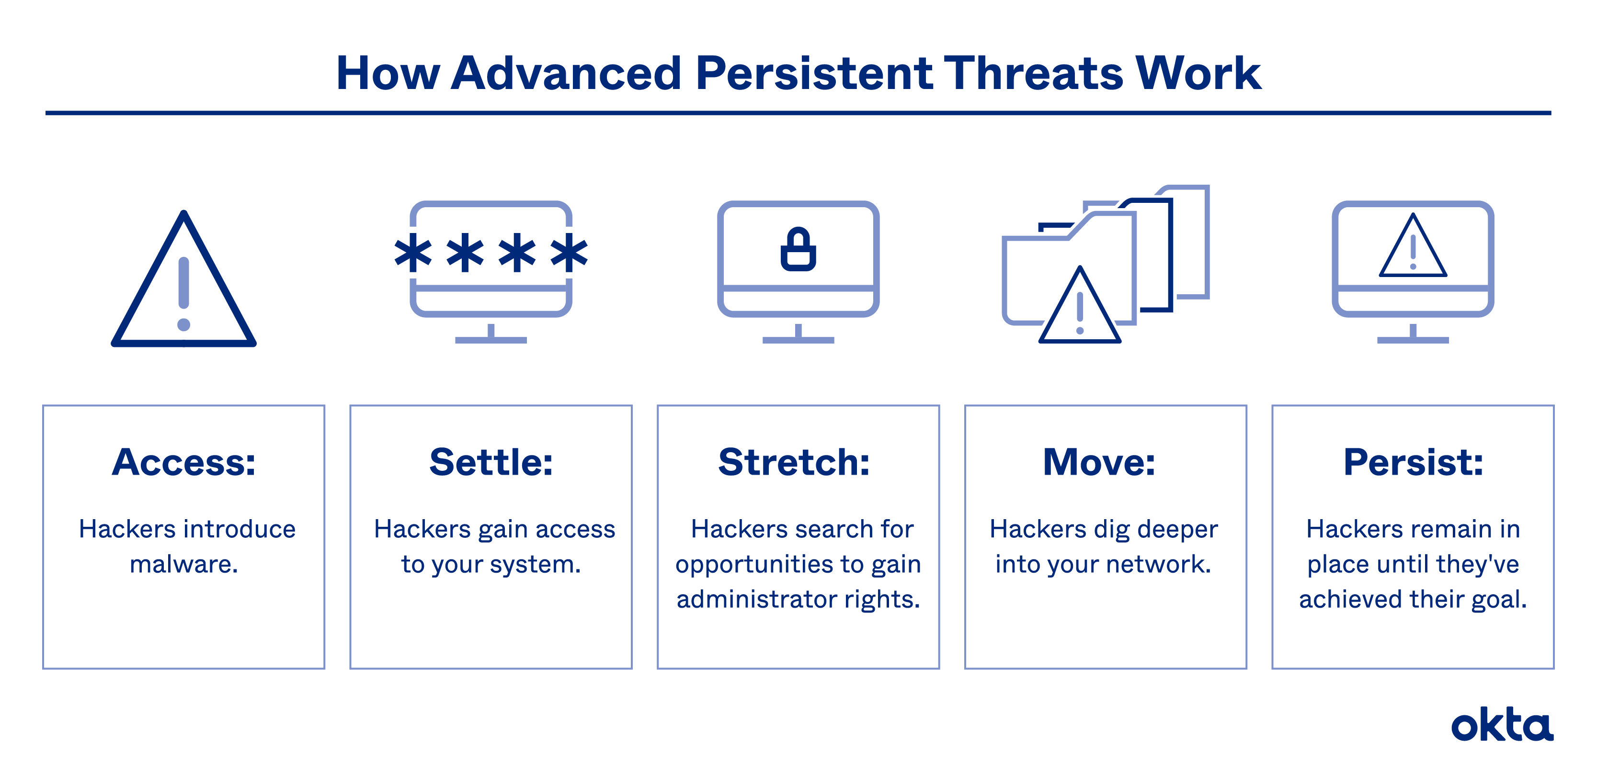

Certainly! Let's delve deeper into the characteristics of APT (Advanced Persistent Threat) attacks:

**1. Advanced Techniques and Tools:**

* APT attackers employ cutting-edge techniques and tools that surpass those used by typical cybercriminals. They develop or acquire sophisticated malware, exploit zero-day vulnerabilities, and use advanced evasion tactics to bypass security measures.
* APT groups may create their own custom malware or modify existing malware to evade detection by antivirus or intrusion detection systems.

**2. Covert and Persistent Operations:**

* APT attacks are designed to be stealthy and persistent, with the goal of maintaining long-term access to the targeted network or system.
* Attackers use various techniques to maintain persistence, such as creating backdoors, establishing command and control (C2) infrastructure, or exploiting weak or misconfigured systems.

3. Targeted Approach:

* APT attacks focus on specific targets, such as government agencies, defense contractors, financial institutions, or organizations with valuable intellectual property or sensitive data.
* Attackers conduct thorough reconnaissance to gather intelligence about the target's infrastructure, employees, partners, and security measures. This information helps them tailor their attack techniques and maximize their chances of success.

4. Multi-Stage Attacks:

* APT attacks typically involve multiple stages, with each stage serving a specific purpose in the attacker's overall strategy.
* The stages may include initial infiltration, reconnaissance, privilege escalation, lateral movement, data exfiltration, and post-exploitation activities. Attackers carefully plan and execute each stage to achieve their objectives.

5. Blending In with Normal Activity:

* APT attackers aim to blend their activities with legitimate network traffic and user behavior to avoid detection.
* They may use encryption, steganography (hiding data within other files), or obfuscation techniques to mask their presence and make it difficult for security systems to identify their malicious activities.

6. Advanced Social Engineering:

* APT attackers employ sophisticated social engineering techniques to gain initial access or escalate privileges within the target organization.
* They may use spear-phishing emails, watering hole attacks (compromising trusted websites), or impersonation tactics to trick employees into revealing sensitive information, clicking on malicious links, or opening infected attachments.

7. Data Exfiltration:

* A primary objective of APT attacks is to steal sensitive data from the target organization.
* Attackers employ various techniques to exfiltrate data, such as using encrypted communication channels, hiding data within seemingly innocuous network traffic, or leveraging compromised external systems as staging points for data theft.

8. Long Duration and Stealthy Operations:

* APT attacks can remain undetected within a victim's network for extended periods, often months or even years.
* Attackers employ techniques to minimize their footprint, cover their tracks, and avoid raising suspicion, making it challenging for defenders to identify their presence.

Understanding these characteristics is crucial for organizations to develop effective defense strategies and implement robust security measures to mitigate the risk of APT attacks. Regular monitoring, threat intelligence sharing, employee training, and strong incident response capabilities are essential to detect and respond to APT threats effectively.

APT Mitigation Stratagies:

Mitigating APT (Advanced Persistent Threat) attacks requires a comprehensive and multi-layered approach. Here are some techniques organizations can employ to enhance their defenses against APT attacks: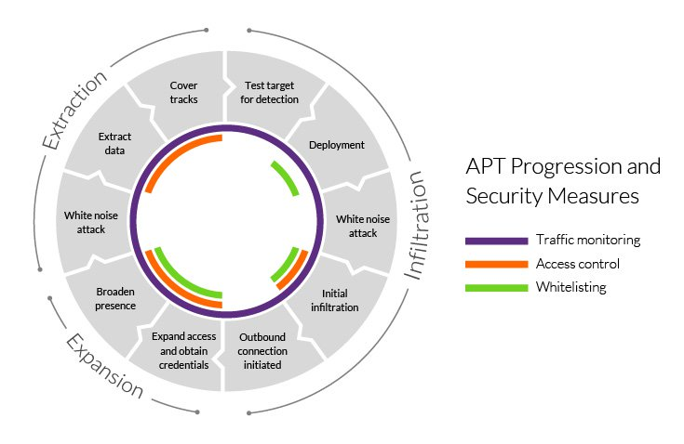

1. Network Segmentation: Implement network segmentation to isolate critical systems and sensitive data from the rest of the network. This limits the lateral movement of attackers and contains the impact of a potential breach.
2. Least Privilege: Follow the principle of least privilege by granting users only the minimum level of access required to perform their tasks. This reduces the risk of attackers escalating privileges and moving laterally within the network.
3. Strong Authentication and Access Controls: Enforce strong authentication mechanisms such as two-factor authentication (2FA) and use robust access controls to restrict access to sensitive systems and data. This helps prevent unauthorized access even if credentials are compromised.
4. Patch and Vulnerability Management: Regularly update and patch software, operating systems, and applications to address known vulnerabilities. This minimizes the risk of attackers exploiting known weaknesses in the infrastructure.
5. Intrusion Detection and Prevention Systems (IDS/IPS): Deploy IDS/IPS solutions to monitor network traffic and identify potential signs of intrusion or suspicious activities. These systems can help detect and block APT attacks in real-time.
6. Endpoint Protection: Implement advanced endpoint protection solutions that include features like host-based firewalls, behavioral monitoring, and threat intelligence integration. This helps detect and prevent APT malware from compromising endpoints.
7. Employee Education and Awareness: Conduct regular cyber security training programs to educate employees about the risks of APT attacks and teach them how to identify and respond to phishing emails, social engineering attempts, and other potential attack vectors.
8. Continuous Monitoring and Penetration Testing: Implement continuous monitoring of the network and perform regular penetration testing to identify vulnerabilities and weaknesses before attackers exploit them. This helps organizations identify and address security gaps and improve their overall resilience against APT attacks.
9. Vendor and Supply Chain Security: Assess the security posture of vendors, partners, and suppliers who have access to critical systems or sensitive data. Ensure they follow best practices and have robust security measures in place to prevent APT attacks that could be initiated through the supply chain.

Remember that APT attacks are highly sophisticated, and there is no foolproof defense. Employing a combination of these techniques, along with regular security updates and proactive monitoring, can significantly improve an organization's ability to detect, respond to, and mitigate the risks posed by APT attacks.